CHIEF MASTER SERGEANT JEREMY A. JENKINS
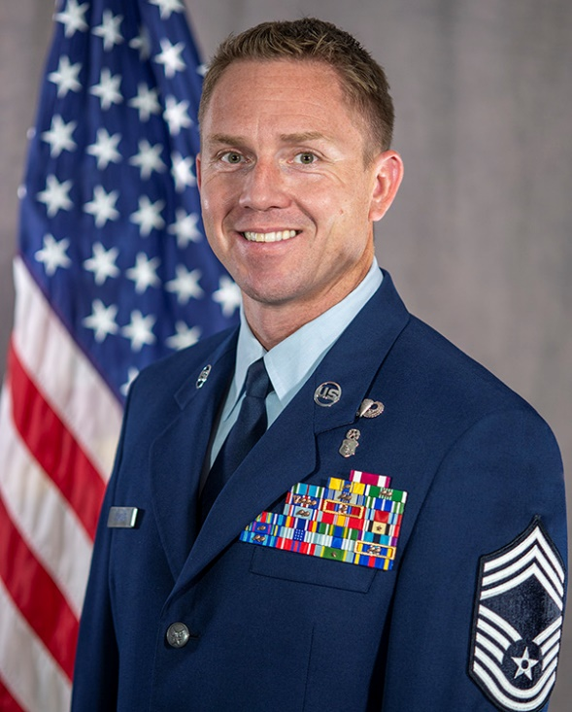
Chief Master Sergeant Jeremy A. Jenkins currently serves as the Senior Enlisted Leader, Colorado Air National Guard Air Staff. On April 6th, 2024, he will assume responsibility as the State Command Chief for the Colorado Air National Guard, Colorado Joint Force Headquarters, Centennial, Colorado. He represents the highest level of Air enlisted leadership and is the principal advisor to the Commander of the Colorado Air National Guard. He is responsible to the commander for readiness, operational utilization, professional development, morale and welfare of more than 1,600 Air National Guard Airmen.

Chief Jenkins enlisted in the United States Air Force in June 1999 as a Tactical Air Control Party (TACP). He graduated Basic Military Training and attended the Tactical Air Command and Control Apprentice Course, Hurlburt Field, Florida. He served 10 years on active duty and conducted numerous combat missions in support of Operations ENDURING FREEDOM & IRAQI FREEDOM. He joined the Colorado Air National Guard in May 2009, where he held several positions including Patient Administration NCOIC, Search & Extraction Flight Chief, Medical Support Squadron Superintendent and Detachment 1 Superintendent in support of Colorado’s Chemical, Biological, Radiological, Nuclear and High Yield Explosive (CBRNE) Enhanced Response Force Package (CERFP). In 2013, he served an active-duty tour in support of the Colorado Joint Counterdrug Task Force where he served as the Senior Enlisted Advisor responsible for overseeing all departments which included civil operations, administration staff, aviation support, criminal analysts, and ground reconnaissance/surveillance specialists in support of local, state and federal drug task forces. Prior to his current position, Chief Jenkins was assigned as the Senior Enlisted Leader (SEL) for the 140th Maintenance Group. Chief Jenkins represented the highest level of enlisted leadership in the Group, advising the commander on all matters concerning the health, morale, welfare and effective management of more than 500 personnel while also developing the future of highly trained maintenance professionals, providing mission capable aircraft and equipment for homeland defense, peace-time training, and warfighting.

As a traditional Drill-Status Guard member, Chief Jenkins civilian experience includes his service with the Denver Police Department where his assignments include patrol officer, district level Narcotics Unit and Detective assigned to the Strategic Investigations Bureau Intelligence Unit where his responsibilities involved complex investigations. Chief Jenkins current assignment is with the Vice/Narcotics Task Force Section.

EDUCATION
1999 Basic Military Training, Lackland AFB, Texas
1999 Tactical Air Command and Control Apprentice Course, Hurlburt Field, Florida
2001 Army SERE, Ft. Campbell AIN, Kentucky
2004 Airman Leadership School, Shaw AFB, S.C.
2005 Joint Firepower Control Course, Nellis AFB, Las Vegas, Nevada
2006 Tactical Air Control Party Craftsman Course, Hurlburt Field, Florida
2008 Associate’s degree in Information Systems Technology, Community College of the Air Force
2010 Health Services Management Apprentice Course, Sheppard AFB, Texas
2013 Noncommissioned Officer Academy, Maxwell AFB, Ala., by correspondence
2017 Associate’s degree in Health Care Management, Community College of the Air Force
2017 Senior Noncommissioned Officer Academy, Maxwell AFB, Ala., by correspondence
2019 Senior Enlisted Joint Professional Military Education I
2019 Senior Enlisted Joint Professional Military Education II
2020 ANG Chief Master Sergeant Orientation Course, Air National Guard Readiness Center, JB Andrews, Md.
2021 Combined Senior Leader Course (CSLC) by correspondence
2021 Chief Master Sergeant Leadership Course, Maxwell AFB, Ala.
2022 Colorado Outreach Exchange (C.O.R.E)
2023 The Rocky Mountain Executive Leadership Academy

ASSIGNMENTS
- January 2000 – February 2002, Battalion Tactical Air Command and Control Specialist, 19th Air Support Operations Squadron (ASOS), Ft. Campbell AIN, Kentucky
- February 2002 – February 2003, Brigade Tactical Air Command and Control Specialist, OL C, 604th ASOS, Camp Humphreys AIN, Republic of Korea
- February 2003 – July 2005, Fighter Duty Technician, 682 ASOS, Shaw AFB, South Carolina
- July 2005 – July 2008, Joint Terminal Attack Controller (JTAC), 3 ASOS, Ft. Wainwright AIN, Alaska
- July 2008 – May 2009, JTAC/Observer-Controller-Trainer (OCT), Joint Readiness Training Center, Ft. Polk AIN, Louisiana
- May 2009 – April 2012, Patient Administration NCOIC, 140 Medical Group, Buckley AFB, Colo.
- April 2012 – March 2014, Search & Extraction Flight Chief, 140 Medical Group Detachment 1, Buckley AFB, Colo.
- April 2013 – December 2015, Senior Enlisted Advisor, Colorado Joint Counter Drug Task Force, Buckley AFB, Colo.
- March 2014 – April 2019, Squadron Superintendent, 140th Medical Support Squadron, Buckley AFB, Colo.
- April 2019 – June 2021, Superintendent, 140 Medical Group Detachment 1, Buckley AFB, Colo.
- June 2021 – July 2023, Senior Enlisted Leader, 140 Maintenance Group, Buckley SFB, Colo.
- August 2023 – April 2024, Senior Enlisted Leader, Colorado Air National Guard Air Staff, Buckley SFB, Colo.
- April 2024 – Present, State Command Chief, Colorado Air National Guard, Joint Force Headquarters, Colo.

MAJOR AWARDS AND DECORATIONS
Meritorious Service Medal with oak leaf cluster
Air Force Commendation Medal with oak leaf cluster
Army Commendation Medal with two oak leaf clusters
Joint Service Achievement Medal
Air Force Achievement Medal with two oak leaf clusters
Army Achievement Medal
Valorous Unit Award with oak leaf cluster

OTHER ACHIEVEMENTS
2004 John L. Levitow Award, Airman Leadership School
2006 Joint Terminal Attack Controller of the Year, 3rd Air Support Operations Squadron
2010 AETC Commander’s Award/Top Graduate, Health Services Management Apprentice Course

EFFECTIVE DATES OF PROMOTION
Airman Basic June 23, 1999
Airman DeC. 23, 1999
Airman First Class OCT. 23, 2000
Senior Airman June 23, 2002
Staff Sergeant April 01, 2004
Technical Sergeant June 06, 2010
Master Sergeant July 13, 2014
Senior Master Sergeant Dec. 03, 2017
Chief Master Sergeant June 13, 2020

(Current as of April 2024)

