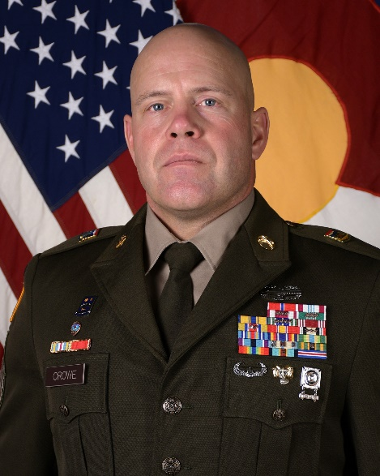**CSM JON T. CROWE**

**Director Joint Staff-Senior Enlisted Leader**

**Joint Task Force Centennial Command Sergeant Major**

CSM Jon Crowe was born in Flint, Michigan and moved to Colorado when he was 3 years old. He enlisted in the United States Army in January 1998. He attended basic training at Fort Sill, Oklahoma and then attended Advanced Individual Training at Fort Bliss, Texas as a PATRIOT Missile Operator and Maintainer. After three years of Active Duty, CSM Crowe enlisted into the Colorado Army National Guard as a Military Police Officer.

CSM Crowe assumed the role as the Senior Enlisted Leader for the Director of the Joint Staff in May of 2024. CSM Crowe previous assignments include Brigade level Command Sergeant Major- 89th Troop Command, Senior Enlisted Leader- Main Command Operational Detachment (MCP-OD)- 1st Infantry Division, Senior Enlisted Leader- Defense Attaché and Military Assistance Program, US Embassy, Amman, Jordan, Command Sergeant Major- 1BN (MTN), 157 Infantry Regiment, 86 IBCT, Command Sergeant Major- 193rd Military Police Battalion, Operations Sergeant Major-193rd Military Police Battalion. CSM Crowe has served in every leadership position from team leader to Command Sergeant Major for multiple Domestic Operations Missions to include wildfires, floods, Hurricane Katrina, Noble Eagle, culminating as a Task Force SEL for the COVID mission in 2020 and later as a team member for creating the LT Governor’s Task Force for COVID contact tracing.

CSM Crowe’s military and civilian education to include the United States Army Sergeant’s Major Academy-NRC-40, Air Assault Course and Basic Military Mountaineer Course. He has a Bachelor of Science degree in Multi-Disciplinary Studies (Summa Cum Laude) from Grantham University.

CSM Crowe’s significant awards include the Bronze Star Medal, Defense Meritorious Service Medal, Meritorious Service Medal (4 oak leaf clusters), Army Commendation Medal (3 oak leaf clusters), Air Force Commendation Medal, Army Achievement Medal (4 oak leaf clusters), Good Conduct Medal, Army Reserve Components Achievement Medal (silver oak leaf cluster and bronze oak leaf cluster), National Defense Medal, Iraq Campaign Medal (3 Bronze Stars), Global War on Terrorism Expeditionary Medal, Global War on Terrorism Service Medal, Armed Forces Service Medal, Humanitarian Service Medal, Armed Forces Reserve Medal (Silver Hourglass and “M” device, numeral 3), Non-Commissioned Officer Professional Development Ribbon (Numeral 5), Army Service Ribbon, Overseas Service Ribbon (Numeral 3), Overseas Training Ribbon, Joint Meritorious Unit Award, Meritorious Unit Citation, Combat Action Badge, Air Assault Badge, Driver’s Badge (2nd Award), the Military Mountaineer Badge (“Ram’s Head”) and numerous State awards. He is the honorable recipient of the Order of St. Maurice-Centurion, the Order of the Marechaussee (Bronze), Norwegian Foot March badge, and the German Armed Forces Badge for Marksmanship (Schutzenschnur)- Gold.

Command Sergeant Major Crowe has been married to wife Christy for over 21 years and has two sons in high school named Thomas and Michael.