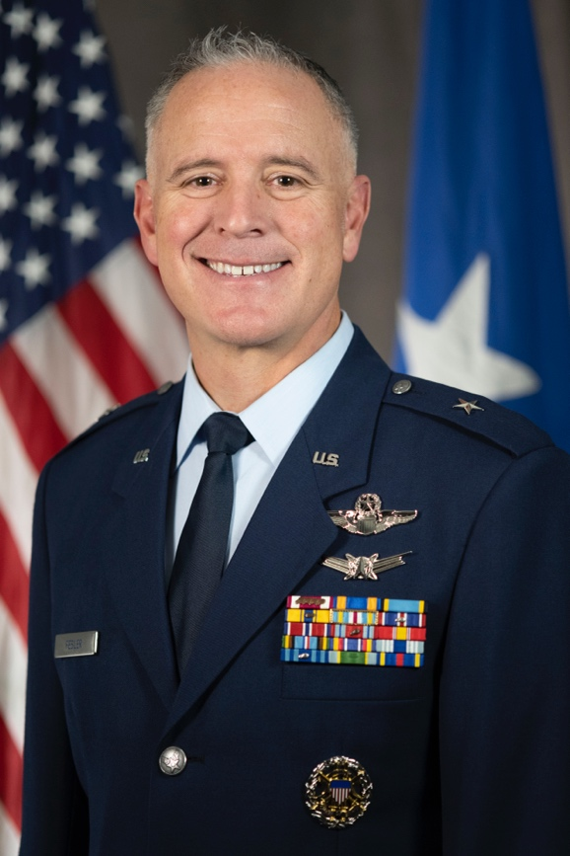
BRIGADIER GENERAL D. MICAH FESLER

Brig. Gen. D. Micah Fesler is the Assistant Adjutant General of Colorado for Air, and the Commander, Colorado Air National Guard, Buckley Space Force Base, Colorado. He is the principal advisor to The Adjutant General on all Colorado Air National Guard matters. General Fesler is responsible for the mission readiness of more than 1,700 military personnel serving at four locations in support of national defense objectives and domestic emergency response operations.

General Fesler also serves as the Air National Guard Assistant to the Director of Operations, Air Combat Command, Joint Base Langley-Eustis, Virginia. Where he advises the Director of Operations on all matters pertaining to the direct operational planning, training, and command and control functions to deploy and employ regular and Reserve component combat air forces, including more than 1,900 aircraft in support of national security objectives.

General Fesler graduated from the University of Utah with a Bachelor of Science in Political Science and earned his commission as a Distinguished Graduate from Air Force ROTC. General Fesler is a graduate of, and instructed at, the United States Air Force Weapons School in both the F-15C and the F-22A. He is a graduate of the National Security Fellowship at the Harvard, John F. Kennedy School of Government and the Massachusetts Institute of Technology, Seminar XXI Fellowship.

Having served in a variety of flying and non-flying operational, educational, training, and staff assignments including multiple tours in the F-15C, F-22A, and F-16C, General Fesler has commanded at both the squadron and wing level. He has participated in numerous joint and coalition exercises and has flown combat in the F-15C and F-22A over Iraq and Syria. Prior to his current assignment, General Fesler served as the Chief of Staff for Air, Colorado Air National Guard, Buckley Space Force Base, Colorado.

EDUCATION
1996 Bachelor of Science Degree in Political Science, University of Utah, Salt Lake City
2003 U.S. Air Force Weapons Instructor Course, Nellis Air Force Base, Nev.
2004 Squadron Officer School, Maxwell AFB, Ala.
2010 Air Command and Staff College, by correspondence
2011 Master of Applied Science, Environmental Policy & Management, University of Denver, Denver, Colo.
2015 Air War College, by correspondence
2017 National Security Fellow, Harvard, John F. Kennedy School of Government, Cambridge, Mass.
2019 Seminar XXI Fellow, Massachusetts Institute of Technology, Cambridge, Mass.
ASSIGNMENTS
1. July 1996 - June 1998, student, Euro NATO Joint Jet Pilot Training (ENJJPT), Sheppard AFB, Texas
2. July 1998 - January 1999, student pilot; Tyndall AFB, Fla.
3. February 1999 - August 2002, F-15C Instructor Pilot and Assistant Chief of Weapons, 19th Fighter Squadron, Elmendorf AFB, Alaska
4. September 2002 - November 2004, F-15C Instructor Pilot and Weapons Officer, 390th Fighter Squadron, Mountain Home Air Force Base, Idaho
5. December 2004 - June 2007, F-15C USAF Weapons School Instructor Pilot and Flight Commander, 433rd Weapons Squadron, Nellis AFB, Nev.
6. July 2007 - December 2009, F-22 Initial Cadre and USAF Weapons School Chief Instructor Pilot, 433rd Weapons Squadron, Nellis AFB, Nev.
7. January 2010 - July 2012, Chief of Advanced Programs, U.S. Air Force Warfare Center, Nellis AFB, Nev.
8. August 2012 - June 2014, Chief Air National Guard 5th Generation Fighter Division, Headquarters Air Combat Command, Langley AFB, Va.
9. July 2014 - June 2016, Commander, 149th Fighter Squadron, Langley AFB, Va.
10. July 2016 - July 2017, National Security Fellow, Harvard, John F. Kennedy School of Government, Cambridge, Mass.
11. July 2017 - May 2018, Director of CNGB Strategic Analysis, Futures, and Initiatives (J59), National Guard Bureau, Pentagon, Washington, D.C.
12. May 2018 – July 2019, Special Access Program Coordinator, Joint Staff J-8, Pentagon, Washington D.C.
13. August 2019 – August 2021, Commander, 140th Wing, Buckley SFB, Co.
14. August 2021 - January 2023, Chief of Staff-Air, Colorado Air National Guard, Buckley Space Force Base, Colorado
15. January 2023 – Present, Assistant Adjutant General-Air, Colorado National Guard, Buckley Space Force Base, Colorado
16. July 2023 – Present, Air National Guard Assistant to the Director of Operations, Air Combat Command, Langley AFB, Va.
FLIGHT INFORMATION
Rating: Command Pilot
Flight hours: More than 2,200
Aircraft flown: T-3, T-37, T-38A, AT-38B, F-15 A/C/D, F-16C/D, F-22A
MAJOR AWARDS AND DECORATIONS
Defense Superior Service Medal
Meritorious Service Medal with four oak leaf clusters
Air Medal
Aerial Achievement Medal
Air Force Commendation Medal with one oak leaf cluster
Joint Meritorious Unit Award
AF Outstanding Unit Award with five oak leaf clusters
Combat Readiness Medal with one oak leaf cluster
Global War on Terrorism Service Medal
Inherent Resolve Campaign Medal

EFFECTIVE DATES OF PROMOTION
Second Lieutenant June 27, 1996
First Lieutenant June 27, 1998
Captain June 27, 2000
Major July 1, 2006
Lieutenant Colonel Aug. 15, 2012
Colonel April 28, 2017
Brigadier General December 31, 2021

(Current as of August 2023)

