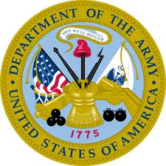
COLONEL
CHARLES Q. BEATTY
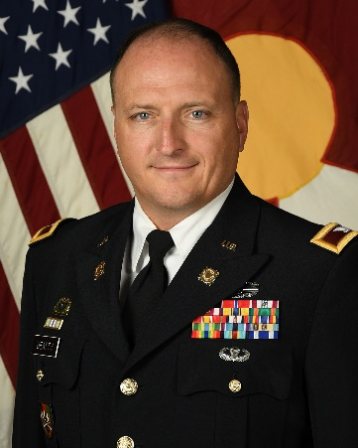
Chief of the Joint Staff
Colorado National Guard

Colonel Charles Q. Beatty assumed his duty as the full-time Chief of the Joint Staff in October 2023. Prior to this assignment, he served as the Director for Military Support (J-3) for the Colorado National Guard.

COL Beatty was born in Englewood, Colorado. He graduated from Regis Jesuit High School in 1991 and Michigan State University in 1995 with a Bachelor of Arts degree in Political Philosophy. COL Beatty spent 3 years after completing his undergraduate education working as a Victim Advocate in the Office of the Denver District Attorney before entering the United States Marine Corps in 1997 through the Officer Candidate School (OCS) program. His military education includes: OCS and USMC Officer Basic School in Quantico, VA; Marine Corps Combat Service Support School at Camp Lejeune, NC; USMC Mountain Survival School in Bridgeport, CA; US Army Airborne School at Ft. Benning, GA; Civil Support Skills Course at Ft. Leonard Wood, MO; US Army Captain’s Career Course at Ft. Lee, VA, the Defense Institute of Security Assistance Management at Wright Patterson AFB, OH, the US Army Command and General Staff College and the US Army Advanced Operations Course. He a Distinguished Graduate of the US Army War College.

COL Beatty began his operational assignments as Battalion Logistics Officer (S-4), Platoon Commander and Company Executive Officer, 1st Combat Engineer Battalion, 1st Marine Division, Camp Pendleton, CA from 1998-2002 where he participated in several division-level exercises, deployed the battalion to the Marine Corps Mountain Warfare Center for a month-long rotation and prepared for the invasion of Iraq in 2003. Immediately before Operation Iraqi Freedom, COL Beatty was re-assigned as Operations Officer, HQ, Western Sector, US Military Entrance Processing Command (USMEPCOM), Aurora, CO where he remained until 2005. COL Beatty left the active duty Marine Corps in 2005 and joined the Colorado Army National Guard. His first assignment was as a traditional Guardsman at Joint Forces Headquarters, G-4, as a staff logistics officer. He soon moved into a position as Detachment Commander, Support Company, 5/19th Special Forces, Watkins, CO where he remained until 2006 when he was selected for the Active Guard and Reserve (AGR) program and began an assignment as Operations Officer, 8th Weapons of Mass Destruction- Civil Support Team (WMD-CST), at Buckley AFB, CO. COL Beatty left the 8th WMD-CST in 2009 to become the Brigade S-4 at 89th Troop Command in Denver, CO. In May 2010 he was selected to deploy on the first-ever US-Slovenian Operational Mentor and Liaison Team (OMLT) as a Mentor for an Afghan infantry battalion in Farah Province, Afghanistan. At the conclusion of his deployment to Afghanistan he was selected to become the Bilateral Affairs Officer in Ljubljana, Slovenia. He served in that capacity as part of the US Office of Defense Cooperation and US Embassy from January 2012 to July 2014, when he was reassigned to Colorado and returned to the 8th WMD-CST to serve as Commander. He held command from February 2015 to June 2017, when he was assigned as the G4 for the Colorado Army National Guard. COL Beatty completed his assignment as G4 in January of 2019 and moved to the G3, where he served for one year prior to assuming his role as Chief of Staff (full-time), where he served for 2 ½ years while also commanding at the Brigade level (M-Day).

COL Beatty’s awards and decorations include: the Legion of Merit, Bronze Star Medal, Defense Meritorious Service Medal (w/ OLC), Meritorious Service Medal (w/ OLC), Air Force Commendation Medal, Navy/Marine Corps Achievement Medal, Slovene Medal for International Cooperation (2nd level), and several others. He has been awarded the Army Combat Action Badge and Army Basic Parachutists Badge.

COL Beatty is married to his college sweetheart, Sarah (Borninski) Beatty, and they have 4 sons: Thomas (21), Ryan (19), Colin (18) and Andrew (14).

